BUDGET TRACKER
BASIC PROGRAMMING FINAL EXAMINATION PROJECT REPORT


By:
MUHAMMAD RAFI PRATAMA (25031553035)
NADYA RENATA SIAHAAN (25031554093)
HISHA AQHILA FADEL WINATA (25031554189)

Lecturer:
Hasanuddin Al-Habib, S.Si., M.Si
STUDY PROGRAM DATA SCIENCE
FACULTY OF MATHEMATICS AND NATURAL SCIENCES
STATE UNIVERSITY OF SURABAYA

Table of Contents
CHAPTER 1. INTRODUCTION 4
1.1 BACKGROUND 4
1.2 PROBLEM STATEMENT 4
1.3 OBJECTIVES 5
1.3.1 Develop a User-Friendly Transaction Recording System 5
1.3.2 Implement Real-Time Financial Visualization 5
1.3.3 Enable Essential Budget Setting and Monitoring 5
1.4 SCOPE AND LIMITATIONS 5
1.4.1 Scope 5
1.4.2 Limitations 6
CHAPTER 2. ANALYSIS AND DESIGN 7
2.1 APPLICATION NECESSITY ANALYSIS 7
2.2 FLOWCHART 7
2.2 UI/UX Design 8
2.2.1 Start Page 8
2.2.2 Login Page 9
2.2.3 Home Page 10
2.2.4 Add Transaction Page 11
2.2.5 Income Page 12
2.2.6 Expense Page 13
CHAPTER 3. IMPLEMENTATION 14
3.1 CODE EXPLANATION 14
3.1.1 Pages Folder 14
3.1.2 Utils Folder 17
3.1.3 Components Folder 19
3.1.4 Design Patterns 23
3.2 USER MANUAL 24
3.2.1 Application Requirements 24
3.2.2 Start Page (Login Page) 24
3.2.3 Home Page (Dashboard) 24
3.2.4 Add Transaction Page 24
3.2.5 Income Page 24
3.2.6 Expense Page 25
3.2.7 Navigation Guide 25
3.3 APPLICATION SCREENSHOTS 25
CHAPTER 4 26
ATTACHMENTS 26
4.1 Embed File 26
References 27

CHAPTER 1. INTRODUCTION

BACKGROUND
Effective personal financial management (PFM) is a crucial determinant of an individual’s financial well-being (Vosloo, 2014). Despite its importance, many individuals, particularly the young generation, often struggle to practice basic financial skills necessary for long-term security, such as budgeting, maintaining a regular savings plan, or planning for future requirements (Birari, 2014). This challenge is compounded by the fact that while people have access to more capital and resources than previous generations, the knowledge required to manage these resources effectively has not kept pace (Fogarty, 2021). he widespread deficit in practical financial skills creates a strong, pervasive need for accessible and systematic methods to monitor, analyze, and control personal spending.
To address this gap, various money tracking and budgeting applications have been developed to replace traditional, cumbersome methods like physical ledgers or complex spreadsheets. These digital tools are designed to simplify the daunting task of PFM. The concept of digital money management tools offers a modern, real-time solution by automating the logging of transactions, providing instant categorization, and generating actionable reports. The development of this money tracker program aims to contribute to this digital landscape by providing users with an intuitive and efficient application designed specifically to cultivate the financial efficacy required for improved financial well-being.

PROBLEM STATEMENT
Despite the widely acknowledged importance of personal financial management (PFM) for achieving financial stability and well-being, a significant number of individuals, particularly the young generation, lack the practical skills for effective budgeting and consistent saving. While the market contains various digital financial tools, many existing solutions are often overly complex, feature-heavy, or inaccessible to users who require a straightforward system for tracking and visualizing basic income and expenses to cultivate financial efficacy. Therefore, this project addresses the challenge of developing a simple, intuitive, and readily accessible digital money tracker program that effectively assists individuals in mastering fundamental financial skills, thereby bridging the gap between available resources and practical financial knowledge.

OBJECTIVES
The primary aim of this project is to develop a functional money tracker program that directly addresses the challenges outlined in the problem statement. The specific objectives that guide this development are:

Develop a User-Friendly Transaction Recording System
To create an intuitive and efficient digital interface that allows users to quickly and accurately input, categorize, and timestamp both income and expense transactions. This objective ensures the application is highly accessible and requires minimal effort for daily data entry, thereby encouraging consistent user practice in financial logging.

Implement Real-Time Financial Visualization
To engineer a core feature that provides users with instant, real-time calculation and visualization of their current balance and cumulative spending patterns (e.g., spending per category, spending over time). This objective aims to provide immediate feedback, which is crucial for increasing financial awareness and efficacy.

Enable Essential Budget Setting and Monitoring
To design and implement a feature allowing users to set monthly spending limits (budgets) for defined expense categories, and to visually track their progress against these limits. This objective specifically focuses on assisting users in practicing control and disciplined financial planning, directly supporting the goal of cultivating core budgeting skills.

SCOPE AND LIMITATIONS

1.4.1 Scope
Fanara Budget Tracking is developed to help users manage their personal finance through a user-friendly interface. The specific capabilities of the system include:
- Transaction Management: Users can record two types of transactions (income and expense) with specific categories and dates.
- Expense Categorization: The program provides defined categories for expenses, such as Food, Transport, Lifestyle, Health, Electrical, Education, and Entertainment, to help users organize their spending.
- Real-Time Balance Calculation: The program automatically updates and displays the Total Balance in IDR immediately after a transaction is saved.

1.4.2 Limitations
Since this project is developed as a fundamental programming assignment, there are certain functional boundaries:
- Linear Transaction History (no filtering): All recorded transactions are displayed in a single, continuous list. The application does not currently support filtering by date (e.g., viewing only "January" or "This Week"). If a user has a large number of transactions (e.g., 100+ items), they must scroll through the entire history to find older entries.
- Static Categories: The expense categories (Food, Transport, etc.) are hard-coded into the system. Users cannot create custom categories or delete existing ones.
- Single Currency Support: The application is designed exclusively for the Indonesian Rupiah (IDR) and does not support multi-currency inssput or conversion rates.
- Local Storage Only: Data is stored locally on the device. There is no cloud backup, meaning if the application is uninstalled or the data file is lost, the transaction history cannot be recovered.

CHAPTER 2. ANALYSIS AND DESIGN

2.1 APPLICATION NECESSITY ANALYSIS
The development of a digital budget tracker application is necessary to address the gap between the increasing availability of financial resources and the limited practical financial skills possessed by many individuals, particularly the younger generation. Although various financial management applications exist, their complexity often limits usability and discourages consistent engagement, especially for users seeking to build basic budgeting and saving habits.
A simple and intuitive budget tracker is therefore required to support fundamental personal financial management by enabling users to monitor income and expenses in a clear and accessible manner. By providing a user-centred and easy-to-use platform, the proposed application facilitates the development of financial awareness and discipline, thereby supporting improved financial decision-making and long-term financial well-being.

2.2 FLOWCHART
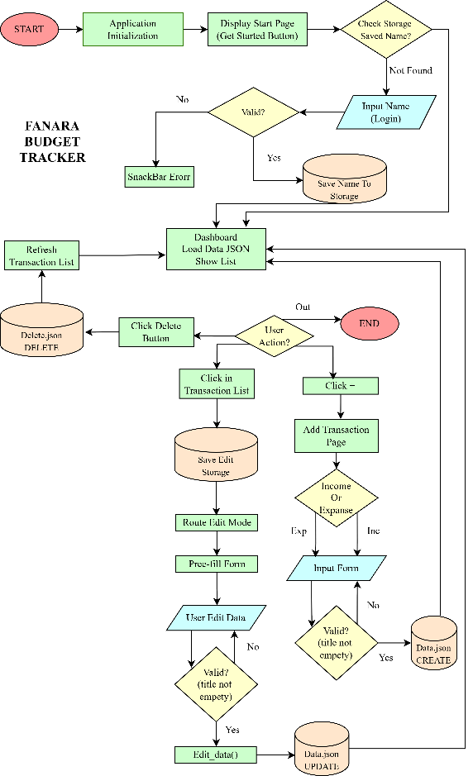
The following flowchart illustrates the complete workflow of the Fanara Budget Tracker application. It details the logic from application initialization and storage checking to the specific user actions for managing transaction data such as adding, editing, and deleting entries.
Figure 2.2. Flowchart

2.2 UI/UX Design
The UI/UX design focuses on simplicity, consistency, and visual hierarchy. Soft color palettes and rounded components are used to create a friendly and modern interface.

2.2.1 Start Page
- Initial entry point
- Projection of logo
Figure 2.2.1. Start Page

2.2.2 Login Page
- Allows users to input their name.
- Minimal design to reduce cognitive load.

Figure 2.2.1. Start Page

2.2.3 Home Page
- Displays total balance, income, and expenses.
- Includes a transaction list and quick access button to add transactions.
- Uses cards to group related information.
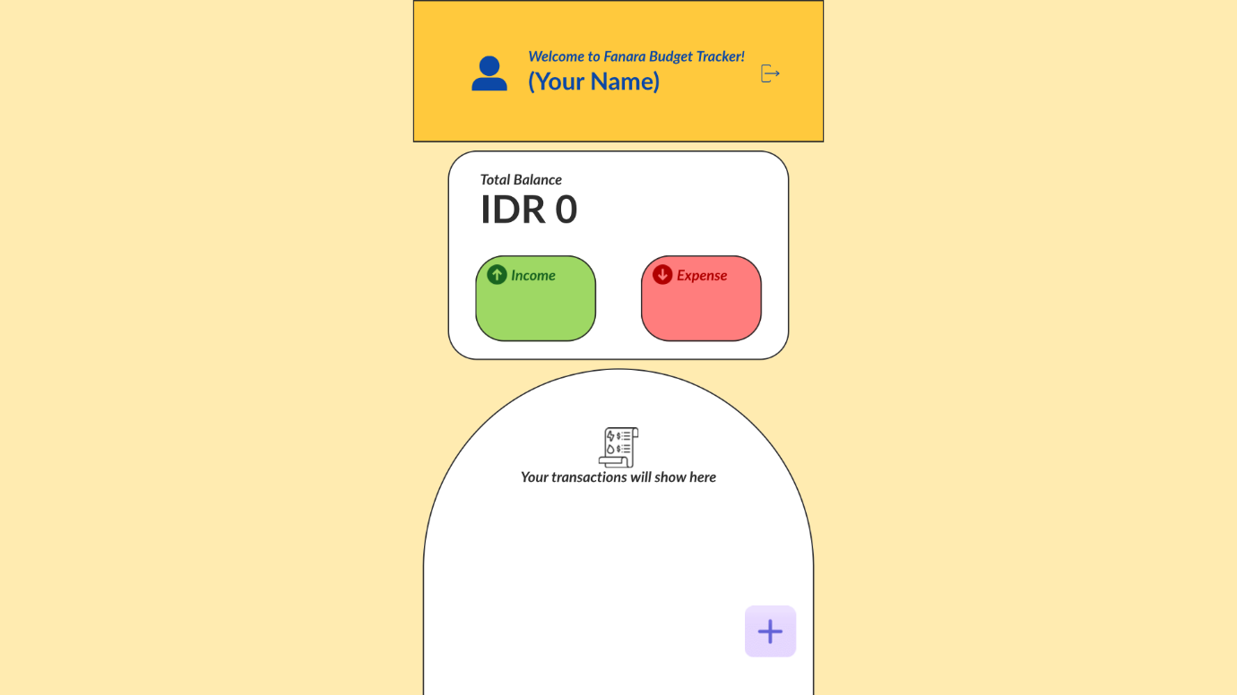
Figure 2.2.3. Home Page

2.2.4 Add Transaction Page
- Provides options to add income or expense.
- Clear icons and color coding help users distinguish transaction type
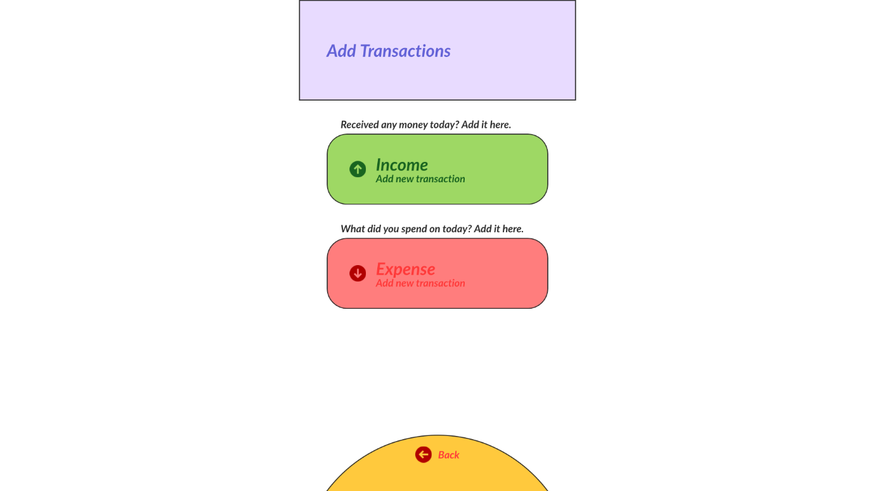
Figure 2.2.4. Add Transaction Page

2.2.5 Income Page
- Record incoming financial transactions
- Provides 4 categories to categorize each income
- Provides title, date, and amount adjustment
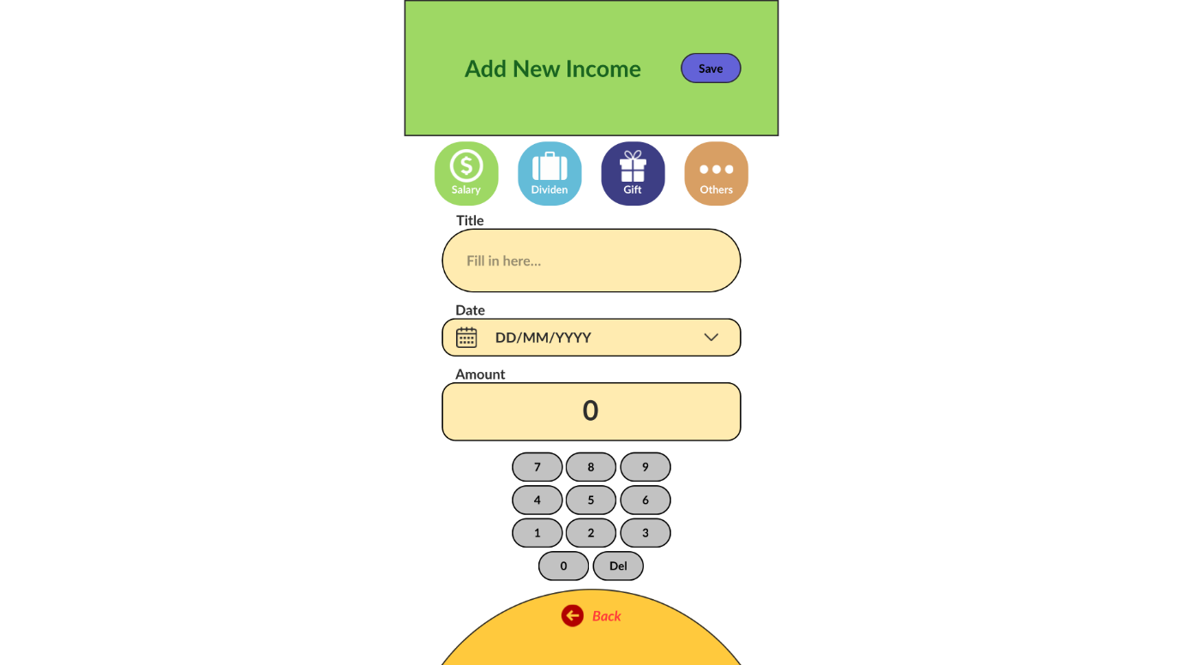
Figure 2.2.5. Income Page

2.2.6 Expense Page
- Used to record outgoing financial transactions
- Provides 8 different categories to group each expenses
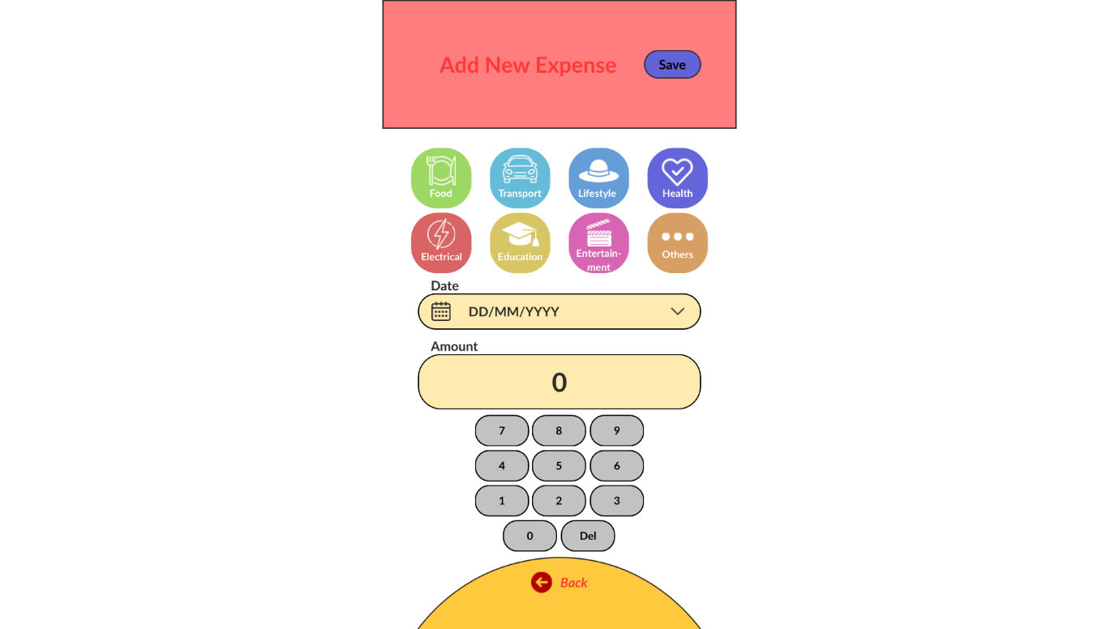
Figure 2.2.6. Expense Page

CHAPTER 3. IMPLEMENTATION

3.1 CODE EXPLANATION
This section will explain the implementation of the crutial codes in the application Fanara Budget Tracker. The explanation will be grouped according to the folder structure to simplify and better understand the system operations.

3.1.1 Pages Folder
Pages folder consists of all main pages of the application that organizes the visualization and interaction with the user.

3.1.1.1 Main Routing System (main.py)
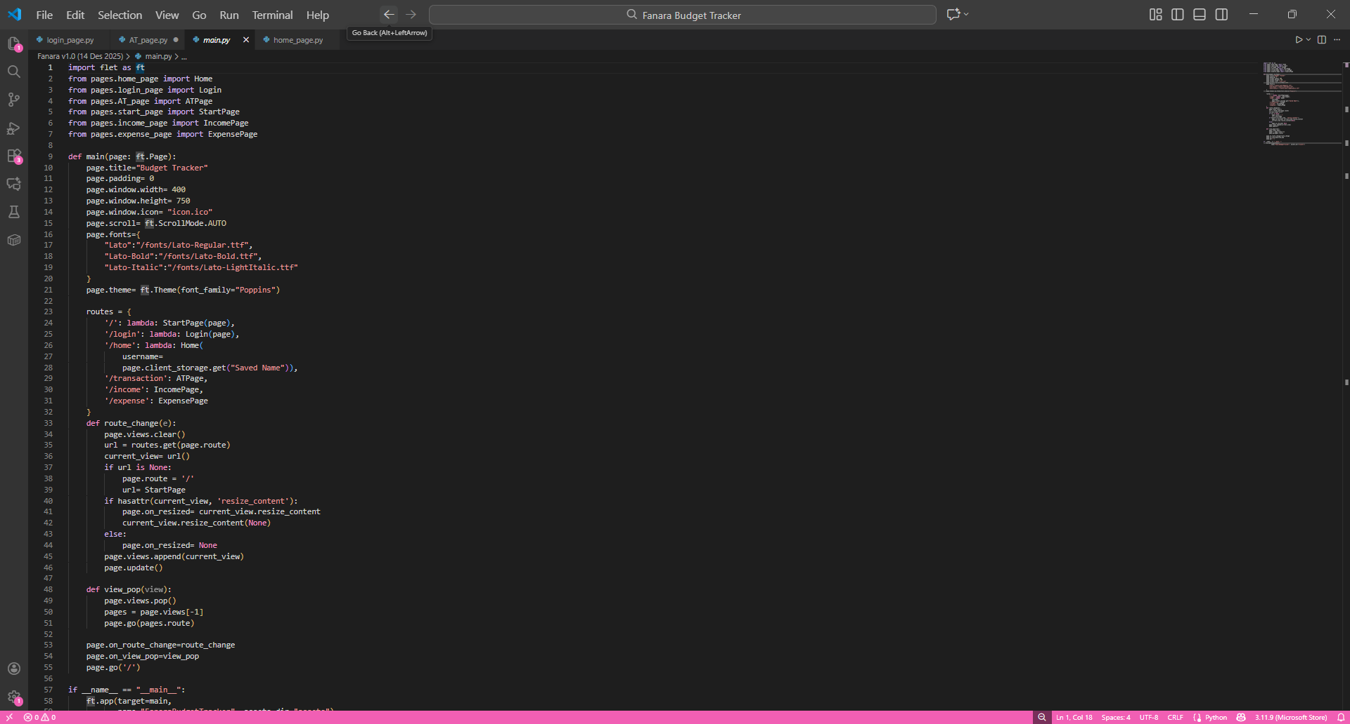
Figure 3.1.1.1. Routing System Implementation

The routing system is a core component that manages navigation between pages in an application. Routing is implemented using a dictionary-based approach to simplify route management. The code utilizes a routes dictionary to map each URL path to the corresponding page. This approach was chosen because it is more scalable than using conditional statements (if-else). Lambda functions are used to enable lazy loading and dynamic parameter passing, such as in the Home page which receives the username from client storage.
The route_change() function is responsible for managing page transitions by first clearing the previous view using page.views.clear(), and then adding the new view. This is crucial to prevent view buildup that could lead to a memory leak.

3.1.1.2 Authentication Flow (start_page.py)
The start page implements logic that checks the user’s login status to determine the appropriate navigation flow.
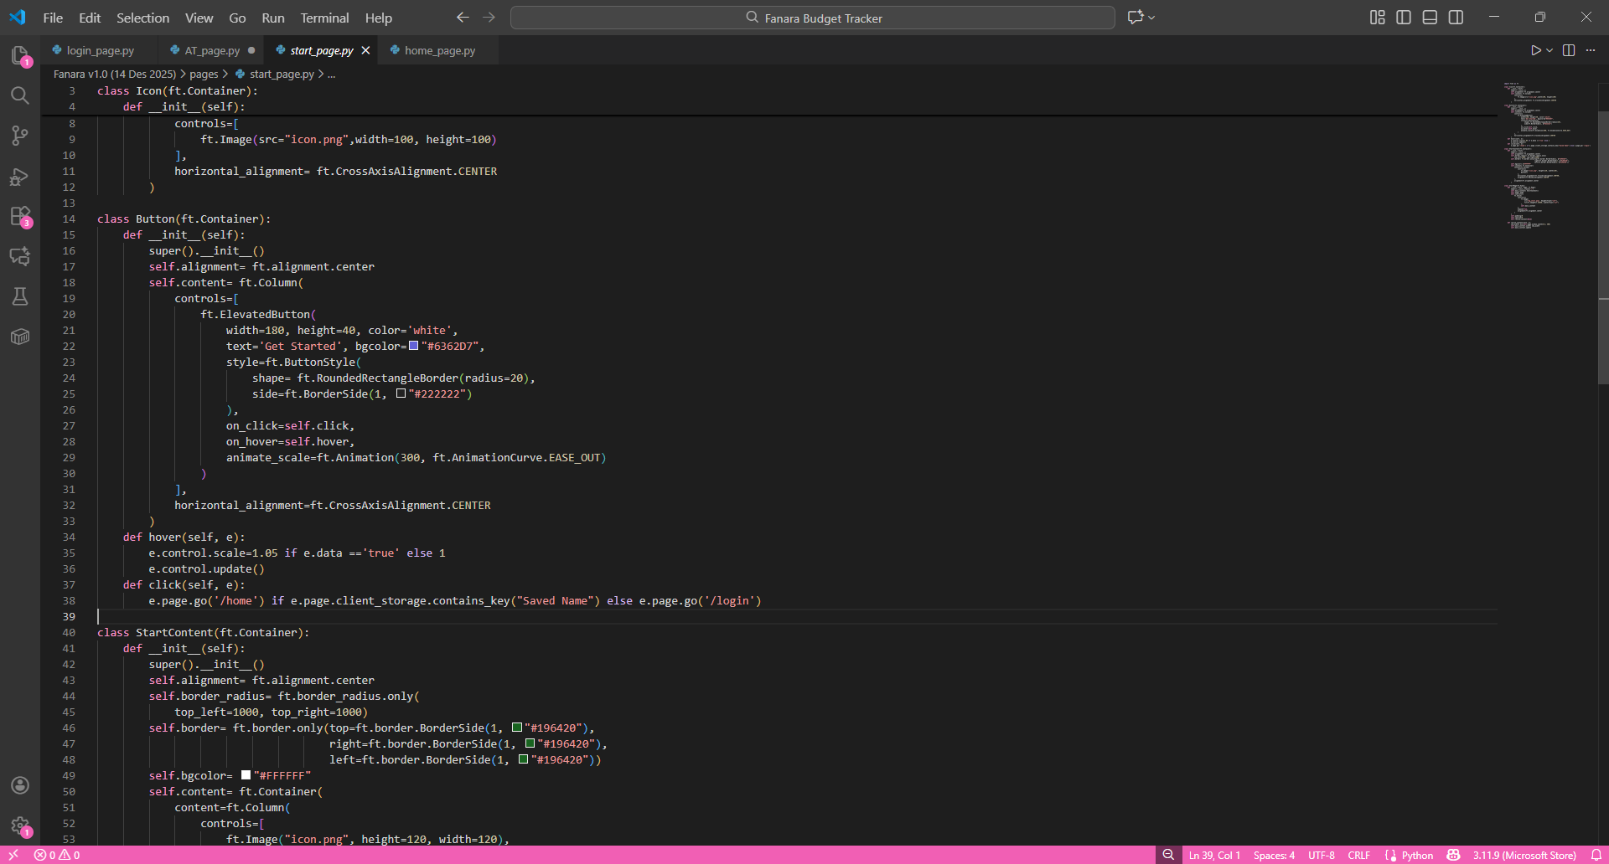
Figure 3.1.1.2. Authentication Check Logic

When the user presses the "Get Started" button, the system will check whether the username is already stored in client storage. If it is already present, the user is immediately directed to the dashboard page. If it is not, the user will be asked to enter their name first on the login page.
This stateless approach was chosen because of its simplicity; it does not require complex session management. Client storage serves as the single source of truth for the user's authentication status, so returning users do not need to log in repeatedly every time they open the application.

3.1.1.3 Dual-Mode Save Logic (income_page.py)
The income page implements save logic that can function in two modes: adding a new transaction (Add) or editing an existing transaction (Edit). This is one of the most complex implementations in the application.
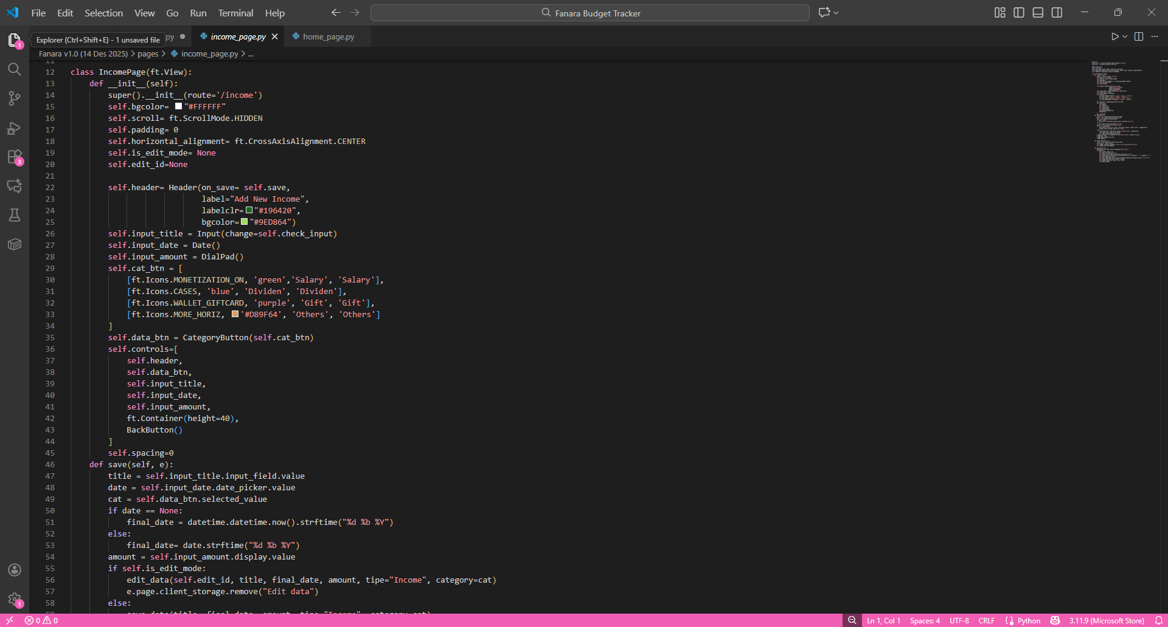
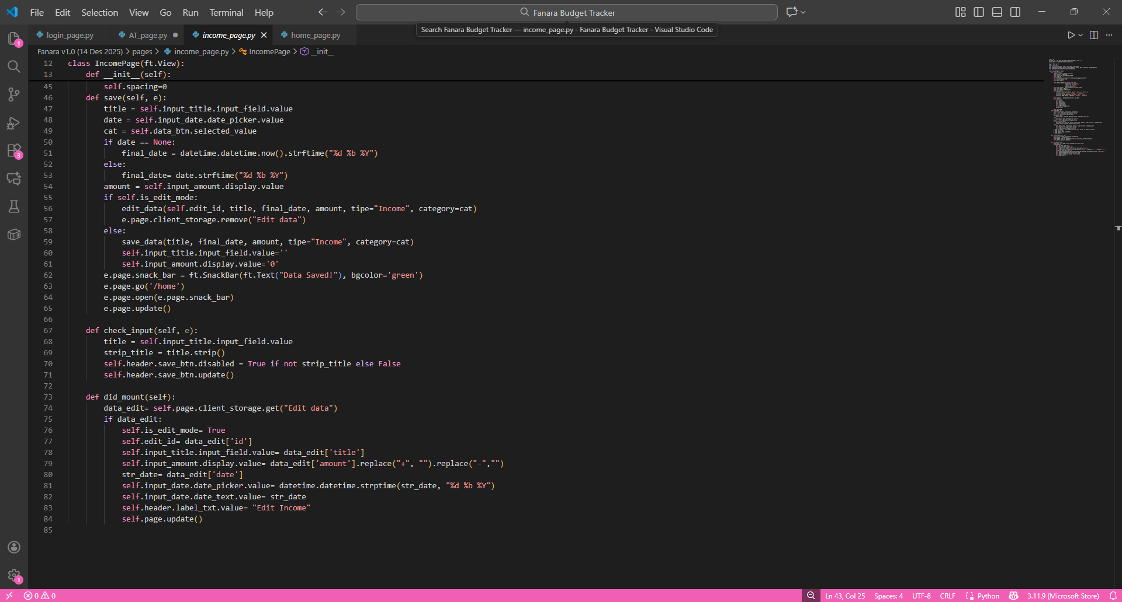
Figure 3.1.1.3. Handler to Add and Transaction Edit

The did_mount() method is a lifecycle method that is automatically called when the page is first rendered. Here, the system checks whether there is any transaction data to be edited in client storage. If there is, the form will be populated with the existing data and the is_edit_mode flag is activated.
In the save() method, the system uses a conditional statement to determine the operation to be performed. If it is in edit mode, it will call the edit_data() function with the saved ID. If it is in add mode, it will call save_data() to create a new transaction. After the edit operation is complete, the temporary data in client storage is deleted to prevent conflicts with subsequent transactions.

3.1.2 Utils Folder
Utils folder contains of utility functions that handles business logic like CRUD and balance calculation.

3.1.2.1 CRUD Operations (transactions.py)
This file implements all the database operations for managing transaction data.
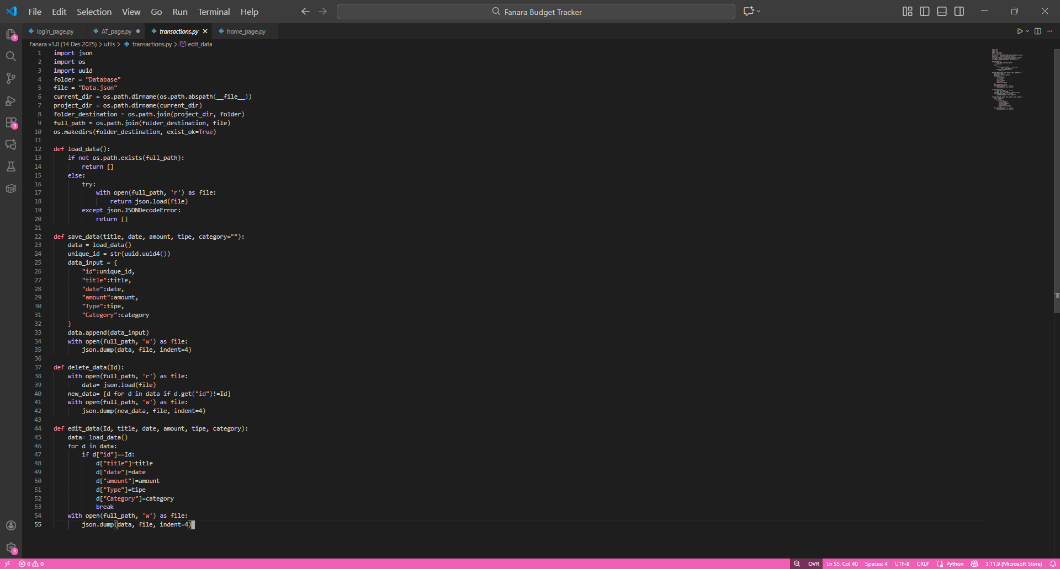
Figure 3.1.2.1. CRUD Implementation for Database

The save_data() function uses UUID (Universally Unique Identifier) to generate a unique ID for each transaction. The use of UUID was chosen because it guarantees the global uniqueness of the ID, so no collision will occur even in concurrent operations.
In the delete_data() function, the deletion operation is performed by creating a new list that only contains data with an ID different from the ID to be deleted. This list comprehension technique is a pythonic and efficient way to filter data. The edit_data() function iterates through all data to find a matching ID. Once the data is found, all fields will be updated and the loop is stopped with a break statement to save unnecessary iterations. All functions use the parameter indent=4 in json.dump() so that the resulting JSON file remains human-readable, which is very useful for debugging purposes.

3.1.2.2 Balance Calculation Engine (summation.py)
This file contains logic to count balance, total income, and total expense that are displayed on the dashboard.
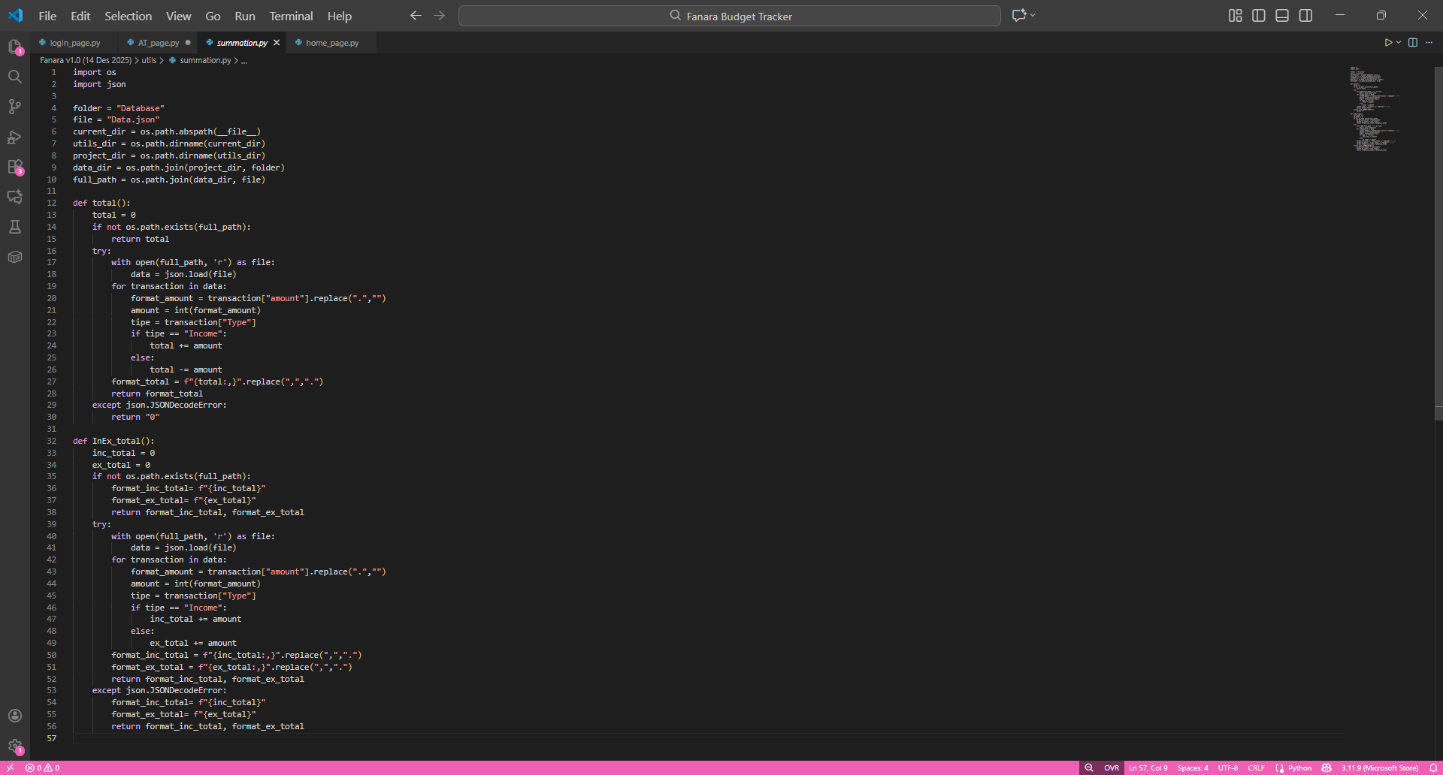
Figure 3.1.2.2. Real-time Balance Calculation
These two functions implement a two-way number formatting process. When reading from storage, the thousands separator (dot) is removed using .replace(".", "") before conversion to an integer. This ensures that the calculation uses the more accurate integer data type and avoids floating point precision issues.
After the calculation is finished, the result is formatted back using the f-string f"\{total:,}" which produces a format with a comma as the thousands separator (international format), then the comma is replaced with a dot using .replace(",", ".") to conform to the Indonesian format. The total() function calculates the net balance with simple logic: income is added and expense is subtracted. Meanwhile, InEx_total() calculates the total income and total expense separately, then returns them in the form of a tuple for use in the dashboard component.
Defensive programming is applied by checking for the existence of the file before opening it and using a try-except block to handle the possibility of corrupted JSON. If an error occurs, the function will return a default value ("0") so that the application continues to run properly.

3.1.3 Components Folder
Components folder contains components of UI that can be reused in multiple pages (reusable components).

3.1.3.1 Interactive Transaction List (transaction_list.py)
This component displays the transaction list in the form of a scrollable list with edit and delete features.
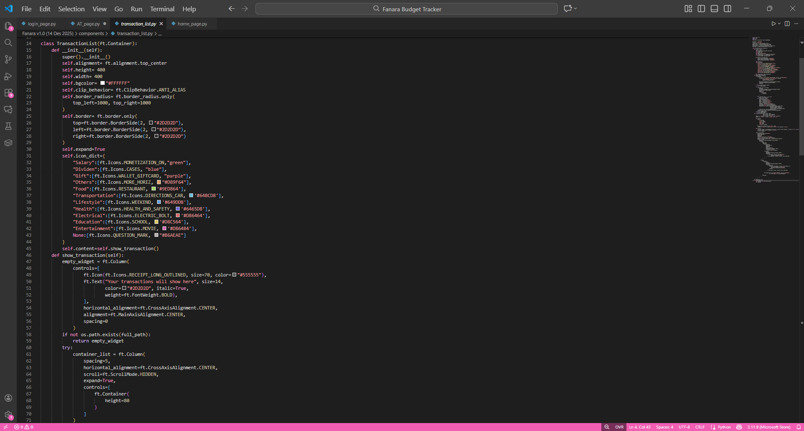Figure 3.1.3.1. Transaction List Component with Interaction (1/3)

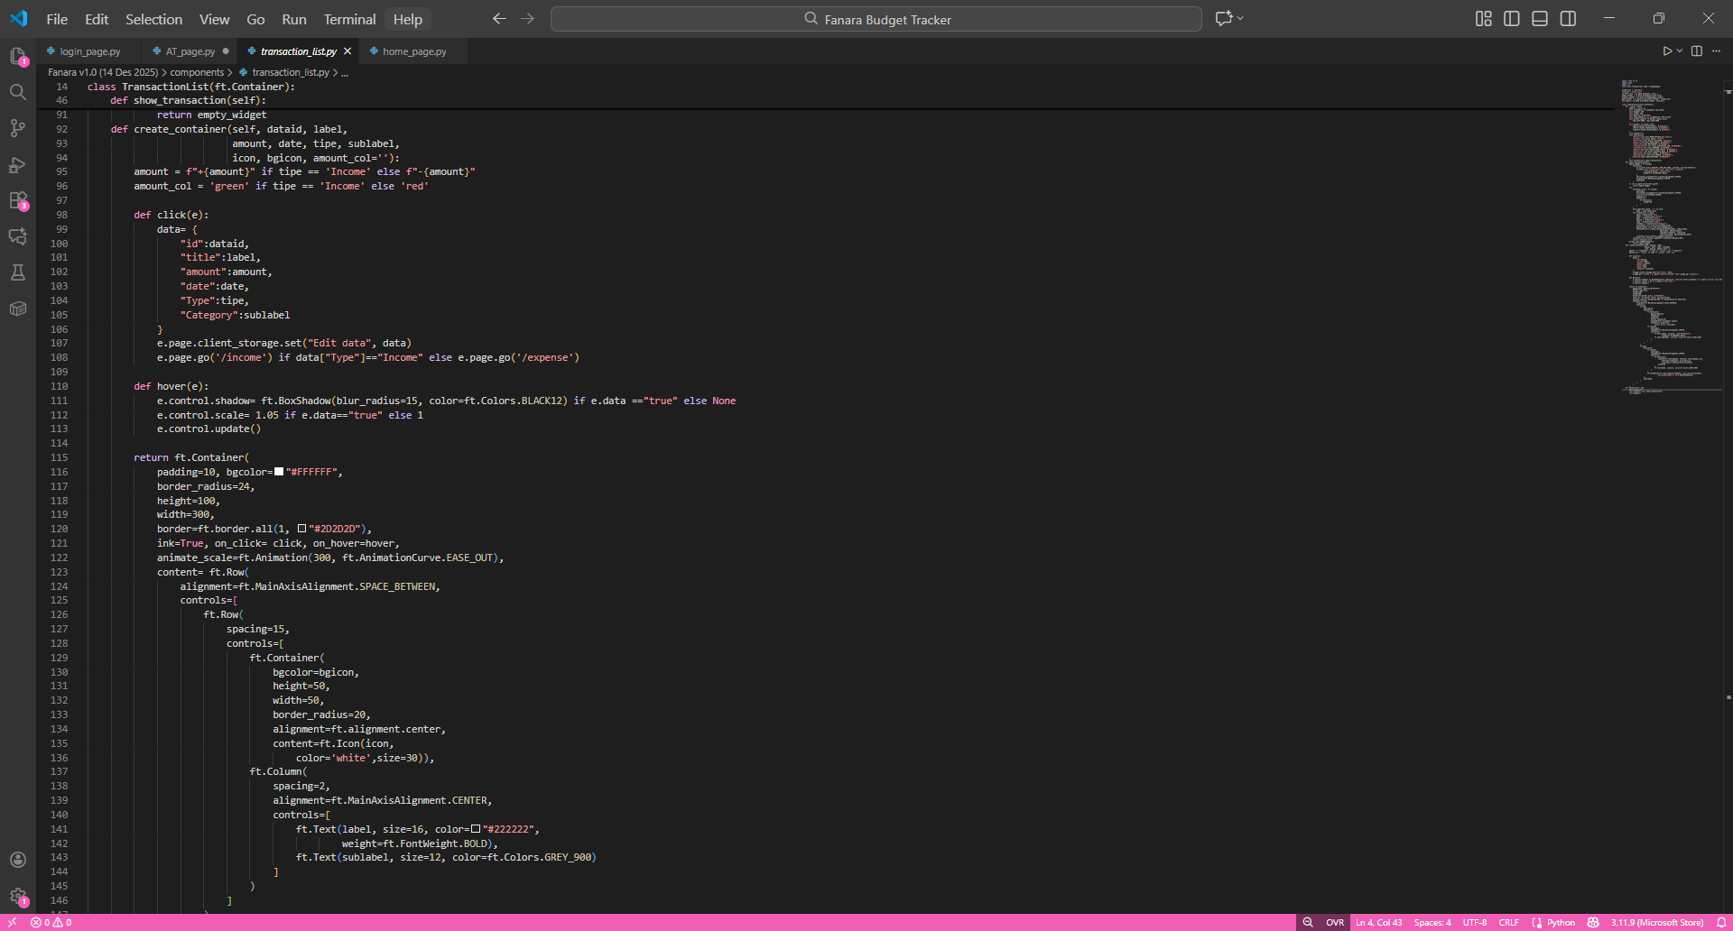Figure 3.1.3.1. Transaction List Component with Interaction (2/3)

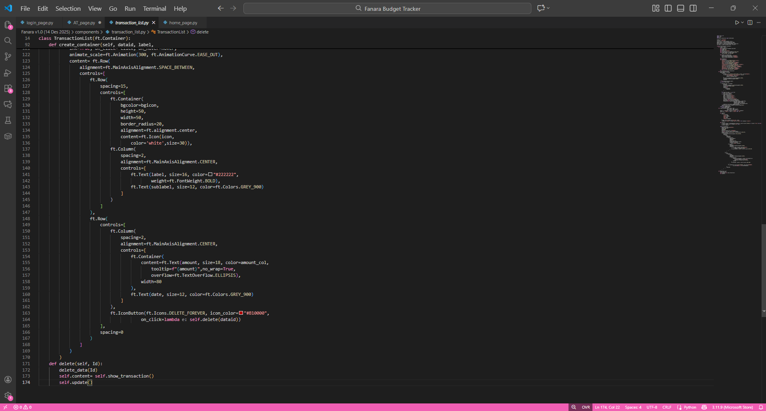Figure 3.1.3.1. Transaction List Component with Interaction (3/3)

The icon\_dict dictionary stores the mapping between transaction categories and the corresponding icon and color. This approach implements the Strategy Pattern—with a single lookup, the system can determine the appropriate visual representation for each category. The None entry functions as a fallback to handle unrecognized categories, preventing a KeyError.
Each transaction is displayed with a different visual based on its type. Income transactions get a "+" prefix with a green color to give a positive impression, while expenses get a "-" prefix with a red color to indicate an outflow. This conditional formatting provides instant visual feedback to the user.
The create\_container() method uses a closure pattern where the click() function is defined inside the method and can access variables from the outer scope. Each card that is created has its own click handler with different data. When a user clicks a transaction, that transaction data is saved to client storage with the key "Edit data," and then the user is directed to the income or expense page according to the transaction's type. On that page, the data will automatically populate the form for editing.
The delete() method removes the transaction from the database and then calls self.update() to refresh the display. This optimistic UI update approach makes the application feel more responsive because the user immediately sees the change without needing a manual refresh.

3.1.3.2 Smart Number Input (commons_IncExp.py)
The DialPad component is a custom number pad with an auto-formatting feature that enhances the user experience during amount input.
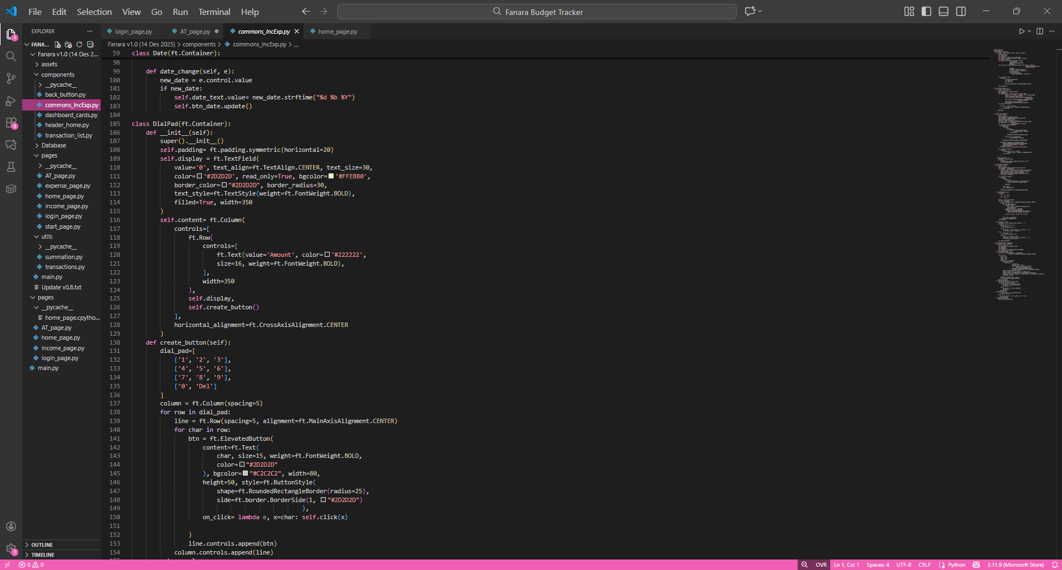Figure 3.1.3.2. DialPad dengan Live Formatting
This component implements real-time formatting where the user can see the correct number format (with thousands separators) while typing, not just after submission. This increases user confidence as they can immediately see the input value in a familiar format.
The displayed value is always formatted (stateless), so there is no need to track separate states for the raw value and the formatted value. Every time there is input, the current value is cleaned of separators, appended with the new digit, and then reformatted. Edge cases are handled well, for example, in the backspace operation: current[:-1] \text{ or } "0" ensures that if the result of slicing is an empty string, it will default to "0". No external libraries are used—all formatting is done with pure Python f-string, thus avoiding dependency overhead.

3.1.3.3 Dynamic Dashboard Card (dashboard_cards.py)
This component displays the financial summary, which is the main information most frequently viewed by users.
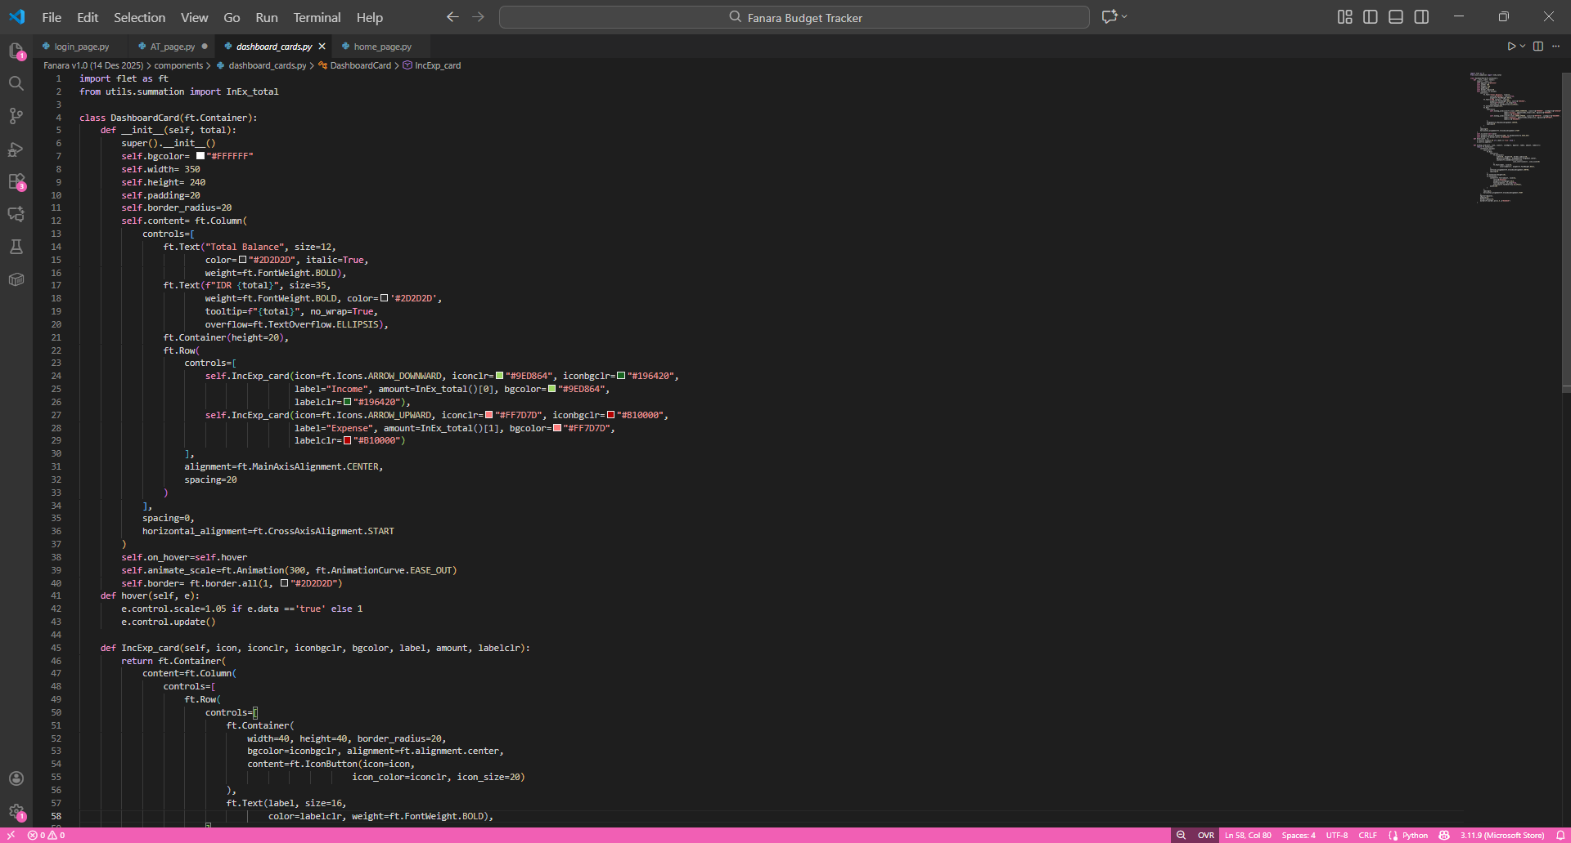
Figure 3.1.3.3. Card Display for Balance Summary

This component implements live data binding; every time the component is rendered, the total() and InEx\_total() functions are called to fetch the latest data from the database. This approach ensures no stale data is displayed to the user. The tooltip parameter is used to manage layout constraints; if the balance value is too long and truncated with ELLIPSIS, the user can see the complete value by hovering. Visual hierarchy is achieved by using a large font size (35) for the Total Balance, making it the most prominent information, while the Income and Expense breakdown is shown in smaller cards below. Color coding (green for income, red for expense) aids quick differentiation. A micro-interaction is added via a subtle hover animation with a 1.05x scale effect, which provides feedback that the elements are interactive and increases the application's perceived responsiveness.

3.1.4 Design Patterns
A few important design patterns that are used consistently throughout the whole application.
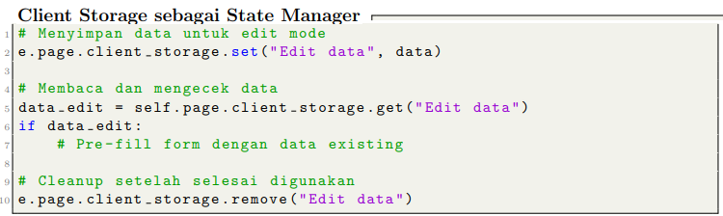
This pattern is used to manage application state without using global variables which are prone to causing race conditions. Data is stored at the page level so that it can be accessed from any component. Cleanup is performed explicitly to prevent memory leaks and data conflicts. This approach is similar to the Redux or Context concepts in React but with a simpler implementation
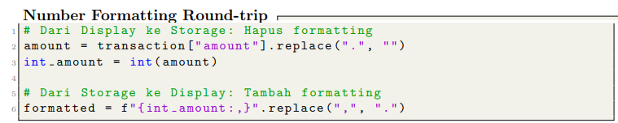
This pattern ensures that calculation always uses the integer data type (which is more accurate and free from floating point issues), while display is always in a user friendly format. One source of truth for formatting logic makes code easy to maintain if the format needs to be changed, just modify in one place only.
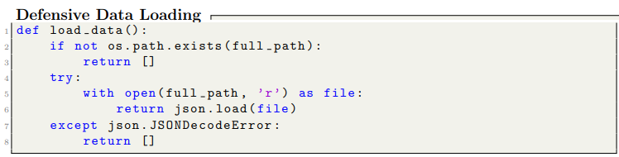
This pattern applies defensive programming by handling various possible errors. If the file is not found (first run scenario), the function returns an empty list. If the JSON is corrupt, it also returns an empty list for graceful degradation. No exceptions are propagated to the UI layer, so all callers can assume that the return value is always valid (in the form of a list).

3.2 USER MANUAL

3.2.1 Application Requirements
- Device capable of running Python applications
- Python installed
- Flet module installed

3.2.2 Start Page (Login Page)
- Enter your name in the input field provided.
- Click the Continue button.
- The application will navigate to the Home Page.

3.2.3 Home Page (Dashboard)
- View your total balance at the top of the screen.
- Check the Income and Expense cards for a financial summary.
- View the transaction list section.
- Press the Add (+) button to add a new transaction.

3.2.4 Add Transaction Page
- Select Income to record money received.
- Select Expense to record money spent.
- The application will redirect you to the selected transaction page.

3.2.5 Income Page
- Enter the income details as required.
- Confirm the transaction.
- The application will return to the Home Page.

3.2.6 Expense Page
- Enter the expense details as required.
- Confirm the transaction.
- The application will return to the Home Page.

3.2.7 Navigation Guide
- Continue Button: Moves from Start Page to Home Page.
- Add (+) Button: Opens the Add Transaction Page.
- Icons and Cards: Indicate income and expense actions.

3.3 APPLICATION SCREENSHOTS

CHAPTER 4

ATTACHMENTS

4.1 Embed File

References
Birari, A. P. (2014). Spending & Saving Habits of Youth in the City of Aurangabad. The SIJ Transactions on Industrial, Financial & Business Management, 158 – 165.
Fogarty, M. (2021). Save, Invest, Grow. Readers Digest.
Vosloo, W. (2014). The relationship between financial efficacy, satisfaction with remuneration and personal financial well-being.

